# St John Vianney, Bexleyheath

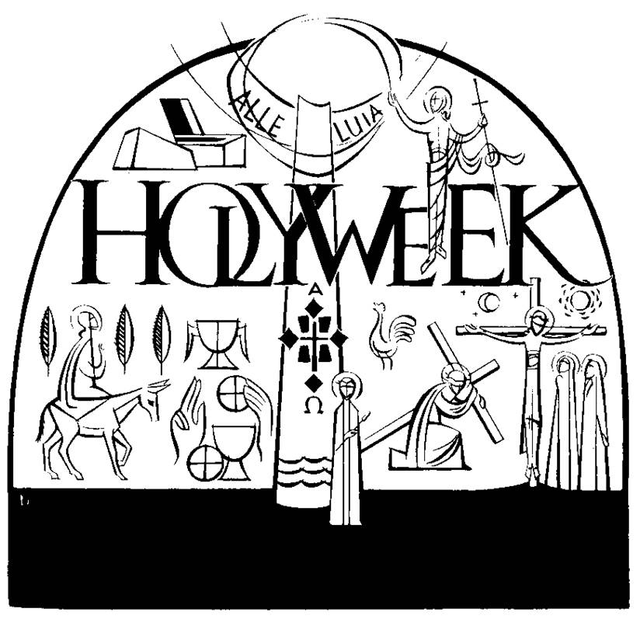

13thApril – 20thapril 2025

Loving God,we are the body of your Son in the world today.As we begin our journey to Calvary give us the courage to carry our crosses.Help us to know that when we suffer we share in the suffering of Christ.Give us the faith to believe that with Christ our crosses never end in death but in the resurrection.As we await Easter Day fill our hearts with joy.We make this prayer through Jesus Christ who is our crucified and risen Saviour for ever and ever.   
**Amen**.



13th April **Palm Sunday- The Passion of Our Lord**

***Palms will be blessed at all Masses.***

8.30am Mass (Fr M)

10.15am – With blessing of Palms starting in the Hall,

then process into the Church for Mass. (Fr L)

5.30pm Mass (Fr M)

**Retiring Collection for Easter Flowers**

14th April **Monday in Holy Week**

9.00am Mass – Confessions available after Mass (Fr L)

15th April **Tuesday in Holy Week**

9.00am Mass - Confessions available after Mass (Fr L)

8.00pm Stations of the Cross

16th April **Wednesday in Holy Week – Spy Wednesday**

9.00am Mass with Adoration until 10.00am (Fr M)

Confessions available after Mass

10.00am Cleaning of the church

*11.30am Mass of Chrism at St George’s Cathedral, Southwark*

6.00pm Practice for Altar Servers

7.30pm Confessions (Fr L)

**The Easter Triduum**

17th April **Maundy Thursday**

No Morning Mass.

7.30pm **Mass of the Lord’s Supper** (Fr M/Fr L)

Holy Oils Procession

Washing of the feet

Watching at the Altar of Repose with Rosary

10pm Compline

18th April **Good Friday**

**A Day of Fasting and Abstinence**

10.00am Stations of the Cross for Children

*10.30am Ecumenical Walk of Witness at Christ Church, Bexleyheath and ends with a service at 11am at the Clock Tower.*

**(Please note: Usual Parking Restrictions Apply in Heathfield Road)**

3.00pm Solemn Liturgy with proclamation of the Passion,

Intercessions, Veneration of the Cross

& Holy Communion (Fr M/Fr L)

**Retiring collection for the Holy Places.**

7.30pm Stations of the Cross (Fr M)

19th April **Holy Saturday**

No Morning Mass

10.00am Morning Prayer with the Office of Readings.

**Confessions**

*11.00 Practice for Altar Servers*

*11.00 Decorating of church (all welcome)*

**The Season of Easter**

19th April **Holy Saturday**

8.00pm **The Easter Vigil (The Holiest Night of the Year)**

Lighting and Blessing of the Easter Fire; Easter Proclamation;

Liturgy of the Word; Blessing of the Easter Water. (Fr M/Fr L)

20th April **Easter Sunday**

**The Resurrection of our Lord Jesus Christ**

8.30am Mass (Fr L)

10.30am Mass (Fr M)

***Following Mass, an Easter Egg Hunt in the garden (£1.00 per child)***

**No Evening Mass**

The Collection at Easter is your personal gift to

Fr Michael and Fr Luke

Small Easter eggs will be distributed to the children after the Easter Masses.

A very joyful and peaceful Easter to you all

From Fr Michael & Fr Luke

