***Volunteering at St John Vianney Catholic Church***

St John Vianney prides itself on being a warm, welcoming and inclusive parish. But like all parishes we need volunteers to help the parish to continue to flourish and successfully grow our community.

We appreciate that everyone leads busy lives these days, however, we are asking you to support the parish by giving a small amount of your time – as much or as little as an hour – as you wish.

It can be fun, meet new friends and make a worthwhile contribution to the parish.

Below are some of the areas in which we need help.

Maybe you have a particular skill you could bring the table i.e. IT, plumber, electrician, surveyor, knowledge of Health and Safety etc.

Sewing skills could also be put to good use as we often need repairs to the servers’ albs.

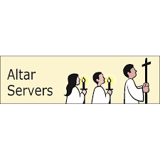

**Altar Servers:**

Help is needed at 8.30am, 10.30am and 5.30pm Masses.

Training will be provided.

**Children’s Liturgy:**

This role entails helping the younger children to understand the Gospel readings at Mass.

* Classes are run at 10.30am Mass. Children leave at the beginning of Mass and return at the Offertory. 2 volunteers are needed, 1 to lead and 1 to assist.
* Simpler readings and literature are used.
* There is a resource cupboard in the small hall from which displays and activities can be made or you can use your own materials.
* You will need to have an up to date DBS for which we can apply.
* Training will be provided.



**Church Cleaners:**

Required once every 3 weeks for 1 hour. This role entails the following:

Sweeping church floors, hoovering the carpets, dusting, emptying bins etc.



**Counters:**

Join the counting team. A rota is provided. Collection(s) are usually counted on a Tuesday morning, record takings and then take to the bank.

**Flower Arranging:**

* Prepare a display for Sunday Mass and put flowers on the Pascal and Peace candles.
* Ensure any dead flowers are removed and replaced with fresh water
* Assist with Easter and Christmas flowers.
* Training will be provided.



**Gardening:**

Help is needed to maintain the Church and Presbytery grounds, thereby making a safe and restful environment. This includes weeding, general tidying up and ensuring that all walkways are clear and safe to walk on etc.

We also welcome donations of plants for the Parish garden.

**Readers:**

Readers are needed at 8.30am, 10.30am and 5.30pm Masses on Sundays and also during the week.

Readers will need to:

* Familiarise yourself with the reading in advance of the service.
* Check that the correct reading is shown at the lectern.
* We usually have one person to read the First Reading and Psalm and a second person to read the Second Reading and the bidding prayers. At 10.30am Mass we sometimes have children reading the Bidding Prayers.
* Training will be provided.

**First Aiders:**

Are you willing to train to be a first aider? Ideally, we need parishioners from each Sunday Mass. Training will be given.

**Sacristans:**

The role is to prepare for Mass:

* Place altar breads and priest’s bread in the ciborium and place on the Credence Table at the rear of the church.
* Ensure there is fresh water and wine in jugs, and put wine jug on the Credence Table too.
* Place the Chalice with clean purificator cloth on the table on the Sanctuary along with the ceramic bowl to wash hands and paper towel.
* Put Tabernacle key in the Tabernacle.
* Light candles on the altar and peace candle before Mass starts
* Ensure the Book of Gospels is on the correct page on the lectern.
* If there have been no altar servers at Mass, return all items to the Sacristy and put the Chalice and Ciborium in the safe.

**Welcomers:**

These are needed for 8.30am, 10.30am and 5.30pm Masses on Sundays. The role entails:

* Distributing Mass books, along with the weekly newsletter and Sunday Plus.
* Organising help for the collection and Offertory Gifts.
* Taking Retiring Collection, if needed.
* At the end of Mass, gather Mass books and store neatly. Place Offertory money and retiring collection in safe in correct bags.
* Ensuring church is locked after everyone has left. (After 8.30am Mass the church is usually left unlocked, as parishioners arrive early for 10.30am Mass)
* After 5.30pm Mass, Fr Michael may require assistance to return to the presbytery during the darker evenings.
* Being a fire warden (training will be provided)

**Fire Wardens:** Ideally, parishioners from each Mass on Sundays. Training will be given.

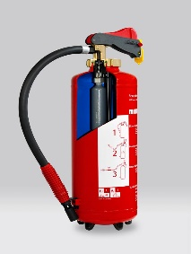

[This Photo](https://en.wikipedia.org/wiki/Fire_extinguisher) by Unknown Author is licensed under [CC BY-SA](https://creativecommons.org/licenses/by-sa/3.0/)

Please do consider giving some of your time to serve the parish and continue to build the community at St John Vianney Church.

If you feel you can help, please complete the back page of this booklet and hand it in today or return it when you’re next at Mass. Alternatively, email: [bexleyheath@rcaos.org.uk](mailto:bexleyheath@rcaos.org.uk).

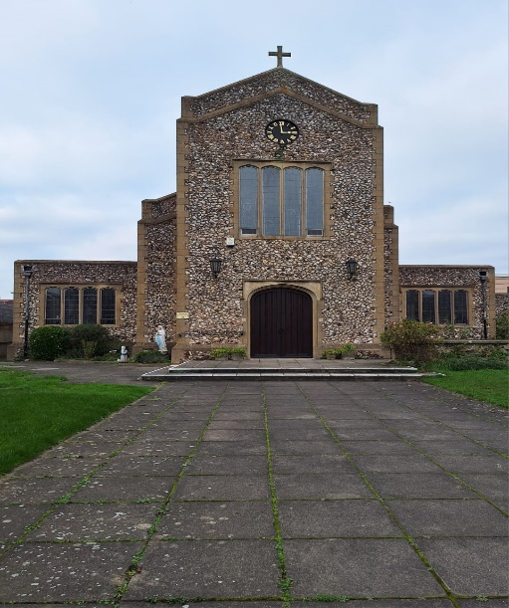

I would like to offer my help at St John Vianney Church.

The area(s) I can help in are:

…………………………………………………………………………………….

…………………………………………………………………………………….

…………………………………………………………………………………….

I have particular skills in:

…………………………………………………………………………………….

…………………………………………………………………………………….

My name is:

……………………………………………………………………………………..

My email is:

……………………………………………………………………………………..

My contact number is:

……………………………………………………………………………………..